Chapter 12, Solution 50.

Hence,

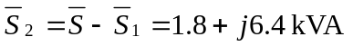
But 